DoConnect AI
Intelligent Discussion & Knowledge Collaboration Platform

Description:
DoConnect AI is a full-stack web-based discussion platform designed to enable users to share knowledge by asking questions, providing answers, and receiving real-time notifications. The system follows a structured architecture similar to enterprise-level applications and supports role-based access control for secure usage.

Project Overview
This project is designed to simulate a real-world Q&A platform like Stack Overflow. It allows users to interact through questions and answers while maintaining proper authentication, user tracking, and notification systems. The platform ensures secure communication using JWT-based authentication and role-based dashboards.

Objectives
The main objective of this system is to create a collaborative environment where users can share technical knowledge efficiently. It focuses on secure login, structured data management, and real-time interaction between users through notifications.
- Enable knowledge sharing
- Provide secure authentication
- Maintain user activity tracking
- Improve communication through notifications

Technologies Used:
The application is developed using modern web technologies to ensure scalability, performance, and security.
Frontend:
- React JS → UI development
- Axios → API communication
- Bootstrap → styling
- Local Storage → session management
Backend:
- Spring Boot → backend framework
- Spring MVC → layered architecture
- Spring Security → authentication
- JWT → token-based security
- Spring Data JPA → database operations
Database:
- MySQL → persistent data storage

System Architecture:
The system follows a layered architecture pattern where each layer has a specific responsibility. This ensures separation of concerns, maintainability, and scalability.

Frontend (React)
↓
Controller Layer (REST APIs)
↓
Service Layer (Business Logic)
↓
Repository Layer (Database Access)
↓
MySQL Database

Additionally:
- Entity Layer → defines database structure
- DTO Layer → handles request/response objects
- Security Layer → manages authentication and authorization

ER Diagram:
An Entity Relationship (ER) Diagram is a visual representation of the database structure that shows how different entities (tables) are connected to each other. It helps in understanding the relationships between data objects and ensures proper database design with minimal redundancy and maximum consistency.
The main entities in the system are:
- User
- Question
- Answer
- Notification
Each entity contains attributes that define its properties, and relationships are established using primary and foreign keys.

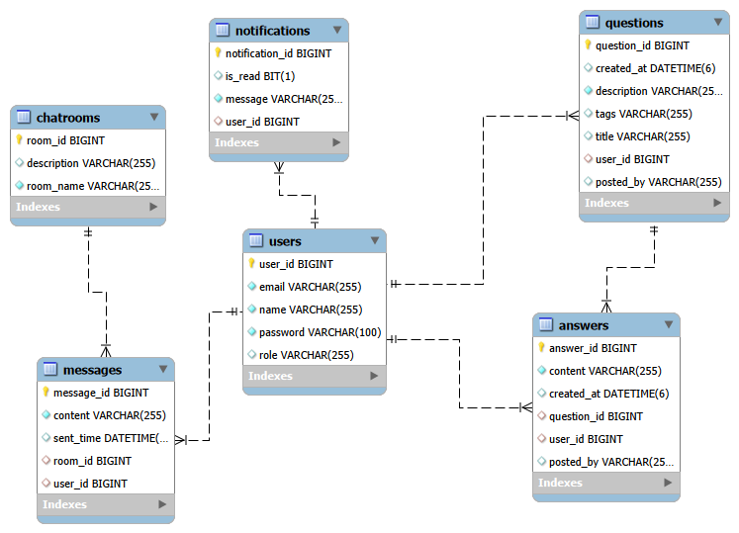

Relationship Description
1. User ↔ Question (1 : Many Relationship)
A User can post multiple Questions, but each Question is posted by only one User.
- This is a one-to-many relationship
- Implemented using postedBy in the Question table (or userId as FK in normalized design)
- It ensures that every question can be traced back to the user who created it
Meaning:
One user can participate actively by asking many questions, but each question belongs to a single user.
2. Question ↔ Answer (1: Many Relationship)
A Question can have multiple Answers, but each Answer belongs to only one Question.
- This is also a one-to-many relationship
- Implemented using questionId as a foreign key in the Answer table
- It ensures all answers are properly grouped under their respective question
Meaning:
Each question can receive multiple responses from different users, supporting collaborative discussion.
3. User ↔ Notification (1: Many Relationship)
A User can receive multiple Notifications, but each Notification belongs to one User.
- This is a one-to-many relationship
- Implemented using userId as a foreign key in the Notification table
- It helps in tracking user-specific alerts and updates
Meaning:
Each user gets personalized notifications based on platform activities such as answers, replies, or updates.
UML Diagrams
UML (Unified Modeling Language) is a standard visual language used to design, describe, and document software systems. It helps developers understand:
- System structure (classes, objects)
- System behavior (flows, interactions)
- Relationships between components

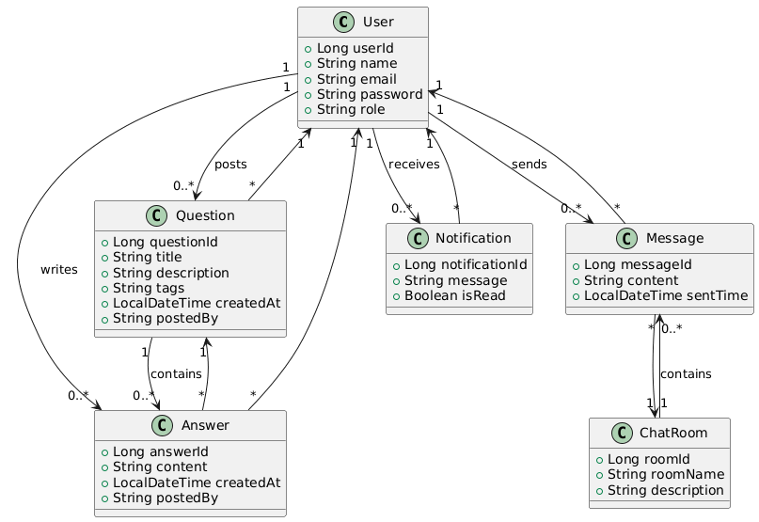

UML is mainly used to represent:
- Users and their activities
- Questions & Answers system
- Messaging system
- Notifications
- Chat system
Type of UML Diagram Used in Project
Your diagram is mainly a:
Class Diagram (Structural UML Diagram)
A Class Diagram shows:
- Classes (entities)
- Attributes (data fields)
- Relationships between classes
It represents the static structure of your system.

Explanation of Your Class Diagram
Your system contains the following main classes:
1. User Class
Represents a system user.
Attributes:
- userId (Long)
- name (String)
- email (String)
- password (String)
- role (String)
Role in system:
- A user can ask questions
- A user can answer questions
- A user can send messages
- A user receives notifications

2. Question Class
Represents questions posted by users.
Attributes:
- questionId
- title
- description
- tags
- createdAt
- postedBy
Relationships:
- One User → Many Questions
- One Question → Many Answers (1 to many)

3. Answer Class
Represents answers to questions.
Attributes:
- answerId
- content
- createdAt
- postedBy
Relationships:
- One Question → Many Answers
- One User → Many Answers

4. Notification Class
Represents system notifications.
Attributes:
- notificationId
- message
- isRead
Relationships:
- One User → Many Notifications (receives)
Purpose:
Used to notify users about:
- New answers
- Messages
- System updates

5. Message Class
Represents chat messages between users.
Attributes:
- messageId
- content
- sentTime
Relationships:
- One User → Many Messages (sends)
- One ChatRoom → Many Messages (contains)
6. ChatRoom Class
Represents a private or group chat space.
Attributes:
- roomId
- roomName
- description
Relationships:
- One ChatRoom → Many Messages

Data Flow Diagrams:
A Data Flow Diagram (DFD) is a graphical representation that shows how data moves through a system. It describes the flow of data between external entities (users or systems), processes, and data storage (databases). DFD helps in understanding how input data is transformed into output through different system components.
DFD does not focus on implementation details like code or hardware. Instead, it focuses on what data is moving, where it is coming from, where it is going, and how it is processed inside the system.

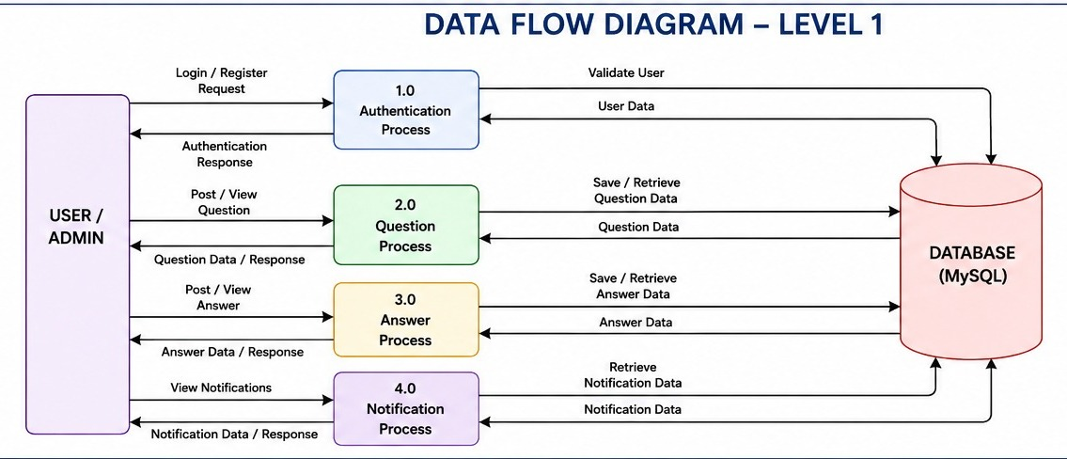

Purpose of DFD
- To visualize system data flow clearly
- To understand system functionality at different levels
- To identify inputs, outputs, and data storage
- To help in system design and documentation
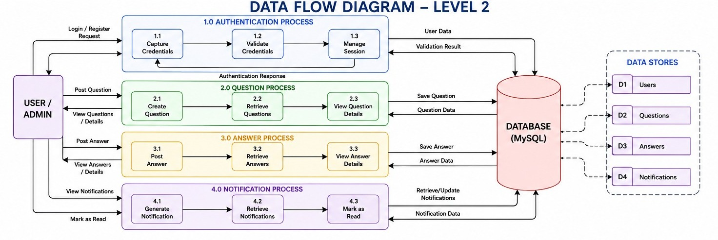

Module Description:

Authentication Module:
This module handles user registration and login functionality. It ensures that only valid users can access the system using JWT-based authentication.
Flow:
- User registers or logs in
- Backend validates credentials
- JWT token is generated
- Token + user details are returned
- Frontend stores session data

User Management Module:
This module manages user-related operations such as storing user details, assigning roles, and tracking user identity across the system.

Question Management Module:
This module allows users to post technical questions and view questions posted by others. Each question is stored with metadata like username and timestamp.
Data Stored:
- Title
- Description
- Tags
- PostedBy (username)
- CreatedAt

Answer Management Module:
This module enables users to provide answers to existing questions. Each answer is linked to a specific question and user.
Business Flow:
- User submits answer
- Backend fetches related question
- Answer is saved in database
- Notification is triggered for question owner

Notification Module:
This module is responsible for notifying users when someone interacts with their question. It enhances user engagement by providing real-time updates.
Flow:
- Answer is submitted
- Backend identifies question owner
- Notification is created
- Message is stored in database
- Notification is displayed in frontend
Admin Module:
The admin module provides control over the entire system. Admin users can view and manage all questions and system data.
Chat Room Module (UI Feature):
This module is a UI-based feature designed for future real-time communication functionality between users.
AI Suggestion Module (Future Enhancement):
This is a placeholder module designed for future implementation of AI-based recommendations for questions and answers.

Backend Architecture:
The backend follows a structured Spring Boot layered architecture that separates responsibilities into different components for better scalability and maintainability.

Controller Layer:
Handles incoming HTTP requests from the frontend and returns responses. It acts as the entry point of the backend system.

Service Layer:
Contains business logic of the application. It processes data before saving or returning it to the controller.

Repository Layer:
Responsible for database operations using Spring Data JPA. It communicates directly with MySQL.

Entity Layer:
Represents database tables in Java objects. It defines relationships between different data models such as User, Question, Answer, and Notification.

Security Layer (JWT):
Provides authentication and authorization using JWT tokens. It ensures secure access to APIs by validating tokens for every request.
DTO Layer:
Used to transfer data between frontend and backend. It ensures that only required data is exposed in API responses.

Frontend Architecture:
The frontend is built using React and follows a component-based structure. Each feature is separated into reusable components for better maintainability.
Pages:
- Login Page
- Register Page
- User Dashboard
- Admin Dashboard
- Ask Question Page
- Question List Page
- Question Details Page
- Notifications Page
- Chat Room Page

State Management:
- React Hooks
- Local Storage for session handling
API Communication:
- Axios is used to communicate with backend APIs
- JWT token is attached in headers for secure requests

Key Features:
The system includes multiple enterprise-level features that make it a complete full-stack application.
- JWT Authentication
- Role-based Access Control
- Question & Answer System
- Notification System
- Timestamp Tracking
- User Activity Tracking
- Admin Dashboard

Business Logic Highlights
The backend automatically handles important operations such as setting timestamps, linking questions and answers, and generating notifications without user intervention.

Security Implementation:
Security is implemented using Spring Security and JWT tokens. Every request is validated to ensure only authorized users can access the system.

Future Enhancements:
The system is designed to be scalable and supports future improvements such as AI integration, real-time chat, and advanced analytics.
- AI-based suggestions
- WebSocket chat system
- Email notifications
- Search optimization

Conclusion

DoConnect AI is a complete full-stack application that demonstrates real-world enterprise development concepts such as authentication, layered architecture, notifications, and role-based access control. It showcases strong backend and frontend integration using modern technologies.

Submitted by:
Name: Makkena Swathika
Role: Project Engineer
Email: makkenaswathika.01@wipro.com
Under Guidance Of:
Guide Name: Javeed Sir
Organization: Wipro
Date: 18-06-2026

